Image | 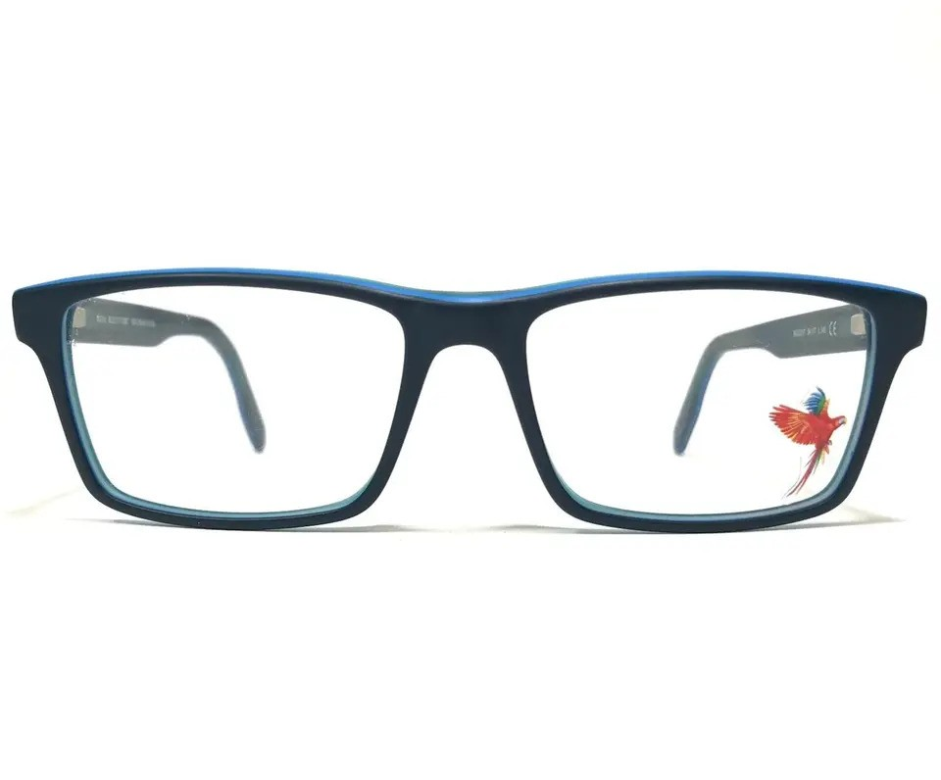
Brand | TIFFANY & CO.
Model Name | MJ 02413
Price | RS 2500
PRODUCT DETAILS

